11.51: a) Take torques about her hind feet. Her fore feet are 0.72 m from her hind feet, and so her fore feet together exert a force of 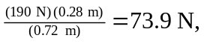 so each foot exerts a force of 36.9 N, keeping an extra figure. Each hind foot then exerts a force of 58.1 N.
b) Again taking torques about the hind feet, the force exerted by the fore feet is 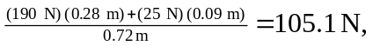 so each fore foot exerts a force of 52.6 N and each hind foot exerts a force of 54.9 N.

